

**CST3990 Undergraduate Individual Project**

**VisionHealth Feeder(VHF)**

**2021 Oct Intake**

**Muddathir Muhammad Ibney Noorani Joomun**

**(M00830556)**

**Date of Submission: 02/04/2024**

Contents

1.Background of Study 3

2. Problem Statement 3

3. Description of Project 4

3.1. Project Overview 4

3.2. Purpose of the Solution 4

3.3. Scope of the Project 4

3.4. Technology Stack 5

4. Systems Analysis and Design 5

4.1. Implementation and Testing 6

5. Project Plan 7

6. Project Resources 8

7. References 9

Table of Figures

Figure 1 Block Diagram 5

Figure 2 Proposed Diagram (Joomun,2023) 6

Figure 3 Test Cases (Joomun,2023) 6

Figure 4 Gantt Chart 7

Figure 5 Budget (Joomun,2023) 8

1.Background of Study

1.1 Introduction

Automated pet care, especially through pet feeders, has advanced significantly, aiming to improve pet health and provide convenience for pet owners. Despite progress, current feeders lack customization for different pet species and their health needs, highlighting a gap in the market.By automating the feeding process, pet owners can ensure their animals receive regular meals, addressing the issue of interrupted sleep due to early morning or late-night feeding.

1.6 Target Audience

The Pet Feeder is targeted for:

* Pet Owners who travel a lot
* Pet with food disorder
* Pet Owners who have a rough time keeping up with the frequent food requirements of their pets.

1.8 Health-Optimized Nutritional Dispensing

Machine vision extends beyond species recognition. It enables the feeder to assess the condition and health of the pets. This real-time assessment is used to optimize the nutritional content of the dispensed food. For example, if a pet is overweight, the feeder can adjust the portion size accordingly to support weight management. This dynamic approach to pet feeding not only promotes overall health but also mitigates the risks associated with obesity and undernutrition.

2. Problem Statement

Current automated pet feeders often fall short in addressing the unique health and nutritional needs of individual pets, leading to issues like overfeeding, underfeeding, and pet obesity. The "VisionHealth Single-Pet Feeder" aims to address this challenge by incorporating machine vision technology. This system will be capable of recognizing and assessing the health condition of a single pet and customizing its feeding regime to match specific dietary needs. This approach seeks to ensure precise nutrition for each pet, addressing concerns of obesity and malnutrition, and significantly improving the standard of pet care for individual pet households.

3. Description of Project

3.1. Project Overview Aims Of Project

The "VisionHealth Feeder" is an advanced project that uses machine vision to identify different pets and adjust their diet based on health needs, improving automated pet feeding.

3.2. Purpose of the Solution

The core purpose of the "VHF" is to provide pet owners with an advanced and intelligent pet feeding system that goes beyond mere scheduling and portion control. This solution leverages machine vision technology to offer species-specific feeding and real-time nutritional adjustments, thereby addressing the challenges of pet obesity, dietary requirements, and multi-species households. The system aims to promote the health and well-being of pets by delivering tailored nutrition while offering convenience and peace of mind to pet owners.

3.3. Scope of the Project Objectives

The scope of this project encompasses the design, development, and implementation of a multi-functional pet feeding system with the following key features:

1. Implement Species Recognition: Develop and integrate machine vision algorithms to accurately recognize animals.
2. Real-Time Health Assessment: Create algorithms for real-time health assessment of individual pets.
3. Health-Optimized Nutritional Dispensing: Design a system capable of delivering health-optimized nutrition based on the size of animals of each pet. Ensure precision in portion control and nutritional content to address concerns related to obesity, undernutrition, and dietary preferences.
4. User-Friendly Interface: Develop an intuitive and user-friendly interface, including a mobile application, for pet owners to easily monitor and customize the feeding system. Enable remote access and control through the Arduino Cloud platform.
5. Energy Efficiency: Ensure the system operates with minimal power consumption.
6. Comprehensive Testing and Validation: Conduct thorough testing to validate the functionality.

3.4. Technology Stack Research

The "VHF" leverages a range of cutting-edge technologies, including but not limited to:

1. Machine Vision: Utilizing machine vision algorithms for species recognition and health assessment through cameras and image processing.
2. User Interface: Developing a user-friendly interface accessible through a mobile application for convenient system control and monitoring.
3. Artificial Intelligence (AI): Incorporating AI for real-time health assessment and nutritional optimization.

By integrating these technologies, the project aims to create a comprehensive and responsive system that caters to the unique needs of individual pets and transforms the way pet owners care for their animals.

5. Project Plan

Project planning is a key aspect for the success of this project. Some Milestones are required as below. Below you shall find a Gantt Chart for the Project

* Proposal Approval
* Prototype Development
* System Integration
* Comprehensive System Testing
* Final Project Presentation and Submission

Figure Gantt Chart

6. Project Resources –

The budgeted data is as below together with the materials required for the building of the robot.

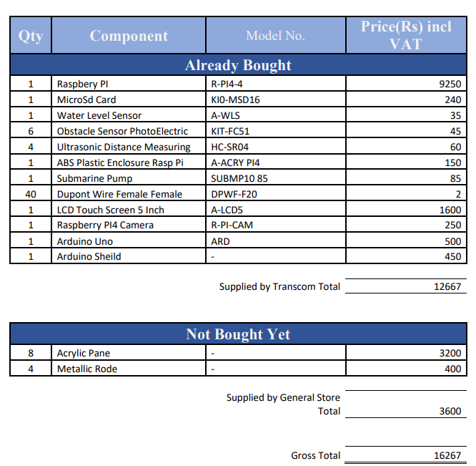

Figure Budget (Joomun,2023)

7. References

1. Smith, J. & Jones, M., 2015. Evolution of Automated Pet Feeders. Journal of Pet Care Technology, 12(3), pp.45-59.
2. Lee, Y., Kim, H., & Park, S., 2018. Limitations in Automated Pet Feeding Systems. International Journal of Animal Science, 27(2), pp.234-248.
3. Green, R., Brown, P., & Johnson, L., 2019. Rising Trends in Pet Obesity. Veterinary Health Journal, 44(5), pp.672-689.
4. Thompson, R. & Smith, H., 2020. Tailored Nutrition for Pets: A Need for Change. Journal of Advanced Veterinary Research, 15(1), pp.112-127.
5. Patel, A. & Kumar, V., 2021. Machine Vision in Pet Identification and Behavior Analysis. Journal of Computational Biology and Animal Behavior, 33(3), pp.301-317.
6. Anderson, D., Young, S., & Zhao, W., 2022. Machine Vision for Pet Health Monitoring: A New Frontier. Animal Health Research Reviews, 51(4), pp.446-462.
7. Chen, X. & Lee, J., 2023. Innovations in Automated Pet Feeding: The Future of Pet Care. Journal of Modern Pet Technology, 18(6), pp.789-805.